[1]

**Wire-Frame Design**

**Concrete Compressive Strength Prediction**

|  |  |
| --- | --- |
| Written By | SHREYAS KHADYE  SUDHANSU GOUDA |
| Version | 1.0 |
| Date | 01/04/2023 |

**Document Change Control Record:**

|  |  |  |  |
| --- | --- | --- | --- |
| **Version** | **Date** | **Author** | **Comments** |
|  |  |  |  |
|  |  |  |  |
|  |  |  |  |
|  |  |  |  |
|  |  |  |  |
|  |  |  |  |
|  |  |  |  |
|  |  |  |  |
|  |  |  |  |
|  |  |  |  |
|  |  |  |  |
|  |  |  |  |
|  |  |  |  |
|  |  |  |  |
|  |  |  |  |
|  |  |  |  |

**Reviews**

|  |  |  |  |
| --- | --- | --- | --- |
| **Version** | **Date** | **Reviewer** | **Comments** |
|  |  |  |  |

### **Approval Status:**

|  |  |  |  |  |
| --- | --- | --- | --- | --- |
| **Version** | **Review date** | **Reviewed By** | **Approved By** | **Comments** |
|  |  |  |  |  |

**Home Page**

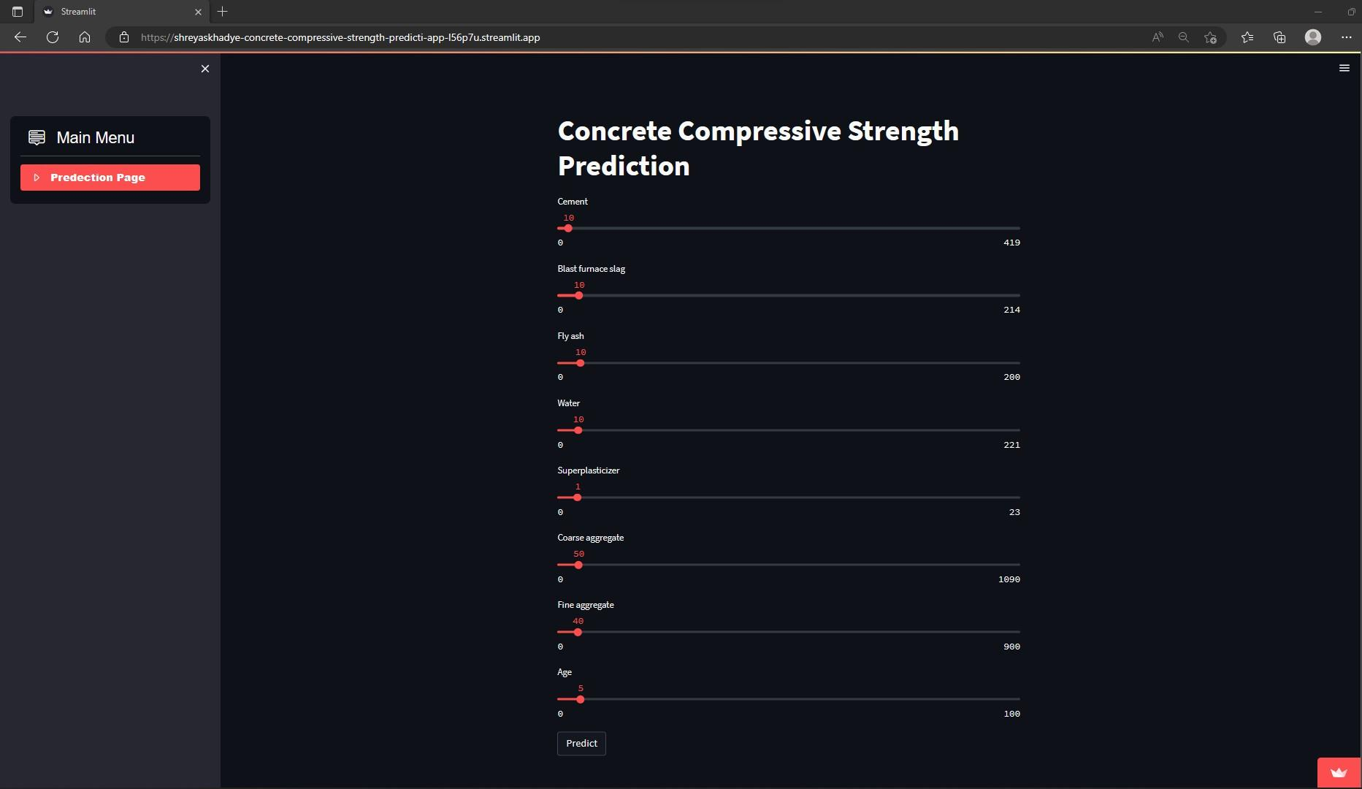

Main Menu

Prediction Page

Concrete Compressive Strength Prediction

Predict

1.